1 A simple circuit.

Task 1a

circuit.m

function dy = circuit(t,y);

% y(1)=Vc_1, y(2)=Vc_2, y(3)=i_L

L = 1 * 10^-5;
C1 = 1 * 10^-5;
C2 = 1 * 10^-5;
global R;

dy = zeros(3,1);
dy(1) = -y(3) / C1;
dy(2) = -(y(3) / C2) - (y(2) / (R*C2));
dy(3) = (y(1) + y(2)) / L;
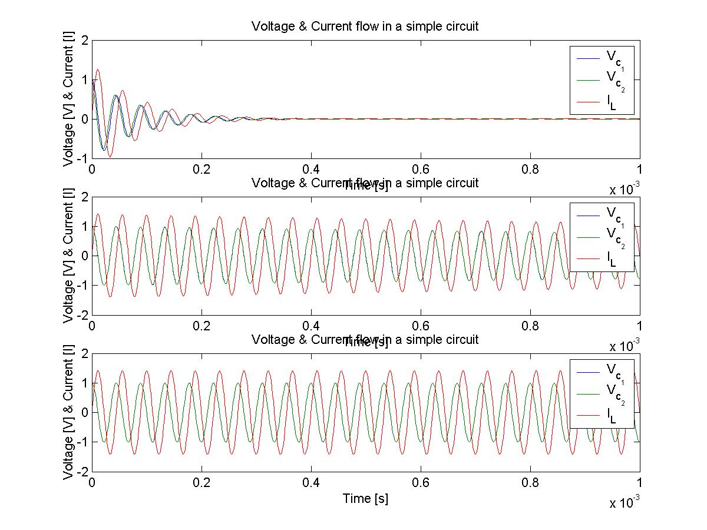

Task 1b
circuit2.m
% This script runs the circuit function declared in task 1a and creates 3 plots with different values % for R.

global R;
R=2;
[t,y]=ode45(@circuit,[0 1*10^-3],[1 1 0]);
figure(1);
subplot(3,1,1);
plot(t,y);
title('Voltage & Current flow in an simple circuit');
xlabel('Time [s]');
ylabel('Voltage [V] & Current [I]');
legend('V_{c_1}','V_{c_2}','I_L');

R=100;
subplot(3,1,2);
[t,y]=ode45(@circuit,[0 1*10^-3],[1 1 0]);
plot(t,y);
title('Voltage & Current flow in an simple circuit');
xlabel('Time [s]');
ylabel('Voltage [V] & Current [I]');
legend('V_{c_1}','V_{c_2}','I_L');

R=10000;
subplot(3,1,3);
[t,y]=ode45(@circuit,[0 1*10^-3],[1 1 0]);
plot(t,y);
title('Voltage & Current flow in an simple circuit');
xlabel('Time [s]');
ylabel('Voltage [V] & Current [I]');
legend('V_{c_1}','V_{c_2}','I_L');

2 Interpolation of tabulated data

Task 1a

y₀ = 11000, y₁ = 10500, y₂ = 10500

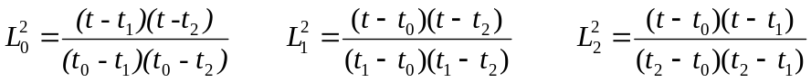

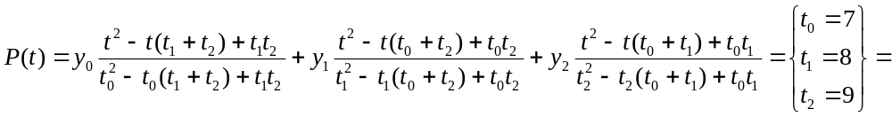

This gives us:

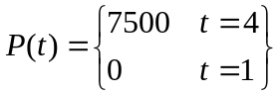

Our conclusion is that this doesn’t seem to be a very good way to interpolate the data, because the approximation isn’t good enough.

Task 2b

t=[1,2,3,4,5,6,7,8,9,10];
y=[10600,11000,10400,9800,10800,11000,10500,10500,10000,8800];
coeff=polyfit(t,y,9);
p=polyval(coeff,linspace(1,10,100));
figure(1);
subplot(2,1,1);
plot(linspace(1,10,100),p);
grid;
title(’Interpolating polynomial plot’);
xlabel(’Month’);
ylabel(’Index’);
subplot(2,1,2);
p=polyval(coeff,linspace(1,12,100));
plot(linspace(1,12,100),p);
grid;
title(’Interpolating polynomial plot’);
xlabel(’Month’);
ylabel(’Index’);
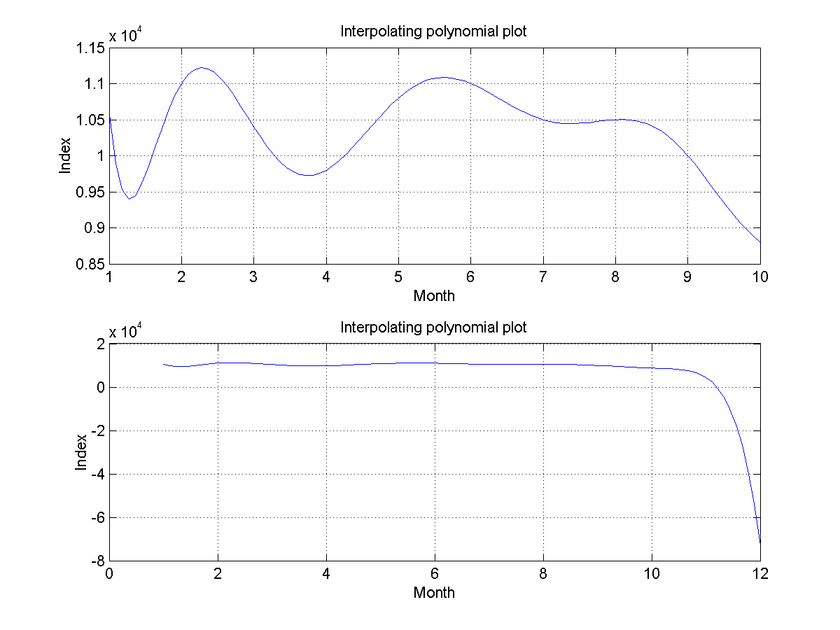
As seen in the figure above the fit is pretty good until November. The error here is due to the last data point that is much lower than the others.

3 Lagrange Polynomials

